Fred Criscuolo
EN605-441 – Summer 2011
fcriscu1@jhu.edu

Genomic Structural Variations In Human Cancer (GSVIHC) Database

- Introduction
  - Scope and Purpose of Document
This document is intended to provide a comprehensive review of the GSVIHC database with particular emphasis on the rationale for its design aspects. The scope of this document will be sufficiently detailed for the user to install their own copy of GSVIHC, develop applications to utilize and maintain the database, and extend the scope of the database for their own requirements.
  - Project Objective
The primary objective of this project was to design and implement a relational database that could support a specific set of specialized requirements and to demonstrate the validity of the design using a set of test queries.
- System Requirements
  - Hardware Requirements

Component | Minimum Requirement | Recommended
Processor | Pentium III or faster
Memory | 1 GB | 4 GB or more
Disk space (database engine) | 711 MB
Pointing device (i.e. mouse) | required

  - Software Requirements
    - Windows operating system
    - .NET Framework 3.5 SP1
    - Microsoft Internet Explorer 6 SP1 or higher (for software installation)
  - Functional Requirements
  - Database Requirements
    - Local System Installation: Microsoft SQL Server 2008 R2
    - Cloud-based Installation: Microsoft SQL Azure (p4vnzoerz7.database.windows.net)

- Database Design Description
  - Design Rationale
The Genomic Structural Variation In Human Cancer (GSVIHC) database (i.e. the database) is a relational database that is responsible for cataloging and annotating the genomic structural variations observed in human cancers. Cancer is a genomic disease characterized by a wide range of structural variations in the genetic and epigenetic compliment of the cell. Variations are determined by comparing an individual’s DNA sequence to a reference sequence. They can be classified as either germline (i.e. parental inheritance) or somatic (i.e. mutations acquired during life). While somatic mutations generally have more priority in cancer studies, germline mutations can affect an individual‘s predisposition to cancer. Genomic structural variations include small changes in the disease cell’s DNA sequence, larger inserts/deletions, copy number variations, severe chromosomal aberrations such as translocations, and changes in chromatin structure (i.e. epigenetic). An important aspect of cancer is that the number and severity of the structural variations increase as the disease progresses and but can also diminish if treatment results in remission. The disease can also move from the primary tissue to a secondary site, usually via lymphatic system (i.e. metastasis).

The primary design objectives for GSVIHC are:
- Model human cancer as a dynamic and evolving pathology
- Support clinicians who need to correlate clinical observations with changes in the genomic structure of patients’ tumors.
- Support researchers who need to understand how a set of genomic structural variations within a tumor impact a cell’s normal function.
- Provide for data model flexibility and extensibility
  - Strong user defined data typing
  - Robust annotation support for clinicians and researchers
  - Reference to external data resources
- A patient data security model that meets patient privacy regulations

The GSVIHC data model can be viewed from two interconnected perspectives. The patient-orientated view consists of entities that contain information about a cancer patient, including the genomic analysis of one or more tissue biopsies. These biopsies, and analysis, are performed over a series of time and the data model supports their lineage by a self-referential relationship for biopsy entries. That is, for a particular patient a later biopsy relates to a predecessor as its parent. This is how the evolution of a tumor is established. A biopsy is classified as to which type of cancer is diagnosed and which tissue type contains the tumor. At least one biopsy and analysis must be performed on tissue known to be normal in order to establish a structural variation baseline. Within a lineage of biopsy analysis the tissue classification may vary if the cancer has metastasized. The patient-related portion of the database also contains an entity that allows authorized clinicians to insert notes and observations related to the patients state and treatments. Examples might include the medications or treatments that a patient is receiving during a period of tumor remission, or details about a familial history of cancer. A described below, all patient related data has restricted access.

The second perspective supports the views of cancer researchers who are interested in what structural variations “drive” cancer and which are “passengers.” These users need an extensive repository of all observed structural variations and an understanding of how these variations affect cellular functions. For example, a mutation that “knocks out” a tumor suppressor gene might result in the overexpression of a second gene leading to unconstrained cell growth. The first mutation might not be directly to the tumor suppressor gene but to some other genomic entity that regulates that gene. These users also have a need to augment or annotate the base data and the data model supports this.

An important design feature in this portion of the database is that it is not gene centric. Rather the concept of a genomic entity is used to provide a finer level of detail of genomic components. Although ultimately a cancer phenotype is caused by the aberrant gene expression, the structural variations that cause this can occur within a growing number of genomic components (e.g. microRNAs, promoters, introns, splice junctions, and methylation patterns). While genes are not the central genomic component, the design contains a gene entity and models how a structural variation affects a gene’s expression.

The two halves of the data model are joined primarily by an entity called StructuralVariationCollection. This entity represents the catalog of structural variations observed from one or more genomic analyses of a tissue biopsy from a particular patient. A single collection represents a snapshot of the mutations with a patient’s tumor and a series of such snapshots demonstrates how genome destructions accumulate as the tumor progresses. This linkage allows the clinician to extend his/her queries to find out more information about the structural variations and the genes affected by them. It also allows to researcher to see the clinical aspects of genome mutations and perhaps correlate structural variation changes with treatments.

A critical design criterion for a scientific database is that it be extensible to accommodate new types and sources of information. GSVIHC supports a high degree of extensibility using three design features. First the data model imposes strong data typing but allows the range of allowable types to be controlled by the users. For example all entries in the PatientBiopsy entity must have at least one relationship to an entry in the Classification entity defining the tissue type for that biopsy. The Classification entry contains a multi-level hierarchy of histological classifications from organ down to a specific cell type. The use of this relationship ensures that the biopsy data are properly classified and that the range of tissue classifications can be readily extended by authorized users. In turn, an entry in the Classification entity must relate to an entry in the ClassificationType entity to identify the type of classification. This supports use of the Classification by a wide range of other entities and supports increasing that range. The ClassificationType entity may contain the name of ontology and a relationship to an ExternalReference for that ontology. The intent is to limit the terminology used with Classifications of that type to the controlled vocabulary of the specified ontology. It is the responsibility of the database curators and/or the application layer to meet this specification. The use of controlled vocabularies supports more consistent querying of the parent entities when compared to a design that has a type column directly in the parent entity. For example, entries within the ClinicalNote entity are constrained by a mandatory relationship to a single ClinicalNoteType. If this design constraint was not in place, one clinician could classify the administration of a medication as a “drug”, another as a “med “, another as an “IV”. Subsequent queries to determine what medications a patient received would be problematic. The use of separate type tables was selected over the use of CHECK constraints on the parent entity in order to support management of type definitions at the application level rather than the database level. CHECK constraints would not provide practical support for the use of published ontologies.

The second design feature that enhances data extensibility is support for a high level of annotations for both clinical and scientific users. Clinicians can annotate their interactions with patients by adding entries to the ClinicalNotes entities. Researchers can annotate the base data in a number of entities by adding entries to the GenomicAnnotation entity. Generally such an annotation should provide its position within the referenced entity. For example if an annotation referred to a splice junction within a DNA sequence, it should specify the starting offset and length of the sequence involved. It may also specify the position and length of that annotation relative to the RNA transcript and or amino acid chain. The specification of UCSC coordinates, will allow a user to reference the position using the UCSC Genome Browser tool. GenomicAnnotations may also reference data on external sources. For example, a researcher might annotate a particular feature and then provide a reference to a scientific paper using NCBI PubMed identifier to substantiate his/her remarks.

The third extensibility design feature is the ability to reference information from a wide variety of local and remote data sources external to the database itself . The ExternalResource entity allows for the definition of data sources that can be accessed by the application layer. These sources can be Web servers, local files, or Web service providers. This federated design eliminates the need for the database to maintain rapidly changing data, and allows the application layer to obtain data from the most reliable source. It also allows application developers to quickly extend the scope of external data. For example, the database does not directly persist the reference sequence for any genomic entity since this information can be readily obtained from the most authoritative source, The Genome Reference Consortium (http://www.ncbi.nlm.nih.gov/projects/genome/assembly/grc/index.shtml). As noted, external resources can be local, an example being a file that can be read by the application layer.

The design features relating to securing patient related data are discussed in detail in the Security section. Although the database does not persist information that could directly identify a patient, access to all patient-related data is restricted to authorized users.

The database supports access to image data (e.g. histological cross-sections, Circos diagrams of genomic mutations) via external references to local or Web-based images. The original design persisted these data within the database as varbinary(max) columns. Based on general design guidelines that discourage incorporating images within the database, the current use of external data was implemented. The use of external resources does provide support for a wider scope of images to be referenced. Storing histological images within the filesystem does introduce a potential patient privacy issue if these images contain patient identification attributes. Deployment of the database and supporting application layer must ensure that these image files are not generally accessible. If a further review determines that privacy vulnerabilities still exist, then there images should be persisted within the database.

  - E/R Model
    - Entities
Entity Name (in alphabetical order) | Description
Classification | A utility child entity that supports a hierarchical classification of a parent entity. A primary classification is required as is a relationship with a ClassificationType entity. More detailed classification is supported via the use of up to four (4) distinct subclasses. An example of how this entity is intended to be use is the specification of a tumor site from organ down to a particular cell type.
ClassificationType | A dictionary entity that provides a controlled vocabulary for the range of Classification entities. This facilitates querying the Classification entity for a particular type of classification (e.g. tumor sites). This entity also supports association the terminology used in a classification to a specific ontology (e.g. Gene Ontology) and may include a relationship a Web reference for that ontology
ClinicalNote | An entity that allows an authorized user to manage clinical information for a particular patient. Such data may include clinical observations, lab results, treatment protocols, etc. Since this entity contains patient related information access is controlled by the user’s authorization level, all changes to these data are intended to be recorded via triggers, and this entity uses the described soft delete model. The intent of these data is to provide an informal correlation between clinical events and observations and the results of genomic analysis. This entity is not intended to replace a patient’s medical chart.
ClinicalNoteType | A dictionary entity that supports a controlled vocabulary for clinical note type (e.g. Symptom, Lab Result, Medication, etc.)
ExternalResource | An entity that supports references to information residing outside the database itself. This information could be on a remote server or be local to the user. The resource_uri attribute may not have sufficient detail to completely specify an external resource. For example, the entry for NCBI Genbank will only specify a base URI, the specific Genbank entry id will be defined in a different entity such as an annotation. It is the responsibility of the application layer to compose a complete URI, access the external resource, and process the results. URIs relating to files will be complete.
Gene | An entity that supports information about a single human gene. The primary key for this entity is HUGO symbol which is considered the universal identifier for a human gene.
GenomicAnalysis | An entity that represents the analysis of genetic material from cells taken in a related patient biopsy. Multiple analyses can be performed using the same biopsy material. There are different types of analysis (e.g. sequencing, micro-array). The entity has a normal_flag attribute to indicate that this analysis was specifically performed on material known to be normal. The purpose of this flag is to readily identify “normal” data for comparison to disease-related data.
GenomicAnnotation | An entity that supports the persistence of a wide range of supplemental data associated with a specified genomic location.  The genomic location may be a specific nucleotide or a range of nucleotides. The entity also supports positioning the annotation on the RNA transcript and/or the translated amino acid sequence. A GenomicAnnotation has an optional text attribute that represents the annotation and it may also have a reference to an external resource. In the latter case, the web_ref_identifier attribute value will be used by the application layer to form a complete URI.
GenomicAnnotationType | A dictionary entity that supports a controlled vocabulary for genomic annotation types Examples include ARTICLE for a journal article, or SEQ for a sequence file.
GenomicEntity | An entity that represents a defined feature within the human genome. A genomic entity has a unique position within the genome (i.e. cytogenetic location). A GenomicEntity may represent a human gene or part of a human gene (e.g. exon). All GenomicEntity entries must relate to one or more Gene entries. For example a micro-RNA entity may be encoded within one gene and down regulate one or more other genes.
GenomicEntityAnnotation | An association table to associate GenomicAnnotation entries with GenomicEntity entries.
GenomicEnitityGenes | An association table to associate GenomicEntity entries with Gene entries. A description attribute is provided to annotate the association (e.g. encodes, down regulates, promotes, etc.)
Patient | An entity that represents a human individual whose genetic material has been analyzed for structural variations. This entity does not contain identifying attributes and access to this entity is intended to be restricted. All changes to attribute values are intended to be automatically audited.
PatientBiopsy | An entity that represents a tissue sample extracted from a patient. The sample may be from material thought to be a malignancy or from known normal tissue. A biopsy has a cell type classification and may have a cancer classification. A critical feature is that a PatientBiopsy entry may have a relationship to a previous PatientBiopsy for the same patient. This self-referential relationship is to support the concepts of tumor evolution and metastasis. A number of Boolean attributes are provided to support rapid aggregation of common collection (e.g. confirmed cancer, metastasis). The entity also supports a reference to an image of a histological cross-section.
PatientDataAudit | An entity that is intended to automatically capture changes to all patient related data including inserts, updates, and (soft) deletes. Included in these audit entries will be a timestamp and user id. This entity is intended for auditing, not for data recovery. It is not intended to be exposed at the application level.
SequenceDataExternalReference | An association entity that links a GenomicAnalysis with external files or Web references that contain the raw or processed analysis data. Since the level of data detail may be sufficient enough to identify the patient, access to a file may be restricted.
StructuralVariation | An entity that represents an observed variation from a specified genomic reference. Such a variation may affect the genomic sequence, the transcribed sequence, and/or the translated amino acid sequence. Such sequence variations must be described in the nomenclature published by the Human Genome Variation Society. A variation might represent a epigenetic event such as a change in a methylation pattern. A StructuralVariation must be classified via a relationship with a Classification entry. A StructuralVariation may be annotated with one or more optional relationships with the GenomicAnnotation entity.
StructuralVariationAnnotation | An association entity that allows a StructualVariation entry to have a relationship with one or more GenomicAnnotation entries.
StructuralVariationCollection | An association entity that represents the set of structural variations observed from the complete set genomic analyses performed on a patient’s biopsy. Each entry has a attributes which support the role of a structural variation in a set. The role of a particular structural variation may change between sets. The loss of heterogeneity attribute (i.e. LOH_flag), if true, means that this structural variation has caused the both alleles for a gene to become identical. The driver_flag attribute, if true, means that this occurrence of the structural variation is deemed to be causing the cancer. The somatic_mut_flag, if true, means that this occurrence of the structural variation is deemed to be somatic (i.e. not inherited from the patient’s parents). The comments attribute is intended to justify or explain these flag settings.
SV_GE_ASSOCIATION | An association entity that supports a many to many association between StructualVariation entries and GenomicEntity entries. A GenomicEntity may have many different structural variations and a StructuralVariation may involve multiple genomic entities (e.g. gene translocations).
UserAccount | An entity that represents registered system users. Users have a specified access leve to patient-related data; the default is none. A user may also be authorized to create GenomicAnnotation entries.

    - Relationships
Parent Entity or Entities | Child Entity | Parent Cardinality | Description
Classification | PatientBiopsy  (cell type) | 1 | Classifies the cell type used for the biopsy
Classification | Patient Biopsy  (cancer type) | 0:1 | Classifies the cancer diagnosis for the biopsy
Classification | StructuralVariation | 1 | Classifies the structural variation
Classification | GenomicEntity | 1 | Classifies the genomic entity
ClassificationType | Classification | 1 | Specifies the type of classification
Patient | PatientBiopsy | 1 | Identifies the source for biopsy material
Patient | ClinicalNote | 1 | Identifies the patient that a clinical note relates to
Patient | PatientDataAudit | 1 | Identifies the patient that the audit data relates to
PatientBiopsy | PatientBiopsy | 0:1 | Maintains a sequence of biopsy data for the same patient to identify disease progression or remission and to provide a link to a normal biopsy
PatientBiopsy | GenomicAnalysis | 1 | Associates a genomic analysis with the biological material that was analyzed.
UserAccount | ClinicalNote | 1 | Identifies the author of a clinical note
UserAccount | GenomicAnnotation | 1 | Identifies the author of a genomic annotation
UserAccount | PatientDataAudit | 1 | Identifies the user who made a change to patient related data
ClinicalNoteType | ClinicalNote | 1 | Specifies the type of clinical note
PatientBiopsy | StructuralVariationCollection | 1 | Identifies the occurrence of an observed structural variation in a genomic analysis
GenomicAnalysis &  ExternalResource | SequenceDataExternalReference | 1  1  (M:N) | Associates external sequence data with a particular genomic analysis
StructuralVariation | StructuralVariationCollection | 1 | Associates the occurrence of a structural variation with data about that variation
StructutalVariation &  GenomicEntity | SV_GE_ASSOVOATION | 1  1  (M:N) | A many to many association between StructuralVariation and GenomicEntity via the SV_GE_ASSOCIATION table
Gene  &  GenomicEntity | GenomicEntiyGenes | 1  1  (M:N) | A many to many association between genes and genomic entities
GenomicAnnotation &  GenomicEntity | GenomicEntityAnnotation | 1  1  (M:N) | A many to many association between genomic annotations and genomic entities
GenomicAnnotation  &  StructuralVariation | StructuralVariationAnnotation | 1  1  (M:N) | A many to many association between genomic annotations and structural variations
ExternalResource | ClassificationType | 0:1 | Allows a ClassificationType to reference a Web-based ontology
ExternalResource | GenomicAnnotation | 0:1 | Allows a GenomicAnnotation to reference an external resource
GenomicAnnotationType | GenomicAnnotation | 1 | Specifies the type of genomic annotation

    - E/R Diagram 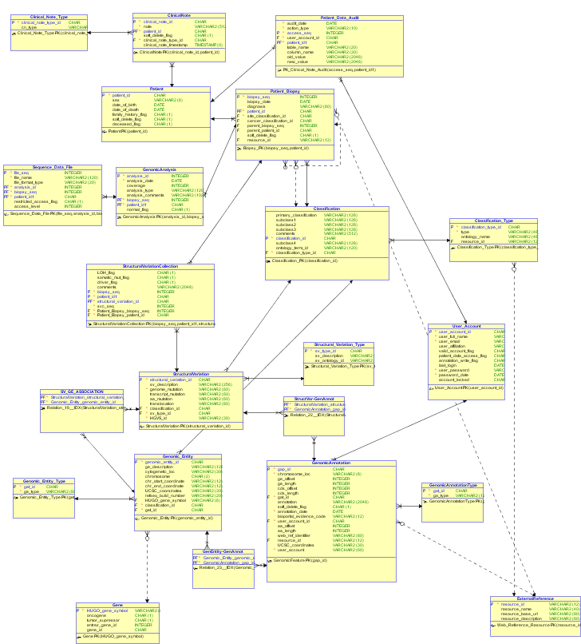
  - Relational Model
    - Data Dictionary

Column | Description | Data  Type | Size | Constraint | Not  NULL | Valid  Values
Classification
classificationId | Primary key | uniqueidentifier | N/A | Primary key | N | N/A
primary_classification |  | varchar | 128 |  | N | Any text
subclass1 |  | varchar | 128 |  | Y | Any text
subclass2 |  | varchar | 128 |  | Y | Any text
subclass3 |  | varchar | 128 |  | Y | Any text
subclass4 |  | varchar | 128 |  | Y | Any text
classification_type | FK to ClassificationType | uniqueidentifier | N/A | FK | N | N/A
ClassificationType
classification_type_id | Primary key | uniqueidentifier | N/A | Primary key | N | N/A
type |  | varchar | 40 |  | N | Any text
ontology_name |  | varchar | 50 |  | Y | Any text
resource_id | FK to ExternalResource | uniqueidentifier | N/A | Foreign key | Y | Any text
ClinicalNote
patient_ id | Primary key  (composite) | uniqueidentifier | N/A | PK | N | N/A
clinical_note_id | Primary key  (composite) | uniqueidentifier | N/A | PK | N | N/A
clinical_note_timestamp |  | datetime |  |  | N
note |  | varchar | 512 |  | N | Any text
soft_delete_flag | Entry is invalid if 1 | bit | 1 |  | N | 0:1
cinical_note_type_id | FK to ClinicalNoteType | uniqueidentifier | N/A | FK | N | N/A
user_account_id | FK to userAccount | uniqueidentifier | N/A | FK | N | N/A
ClinicalNoteType
clinical_note_type_id | Primary key | uniqueidentifier | N/A | PK | N | N/A
cn_type |  | varchar | 50 |  | N | Any text
ExternalResource
resource_id | Primary key | uniqueidentifier | N/A | PK | N | N/A
resource_type |  | Varchar | 50 |  | N | N/A
resource_uri |  | varchar | 80 |  | N | URI format
resource_desctiption |  | varchar | 80 |  | Y | Any text
Gene
HUGO_Gene_symbol | Primary key | varchar | 8 | PK | N | Valid HUGO symbol
Oncogene_flag | Known oncogene | bit | 1 |  | N | 0:1
Tumor_suppressor_flag | Known tumor suppressor | bit | 1 |  | N | 0:1
Cell_cycle_flag | Cell cycle pathway gene | bit | 1 |  | N | 0:1
Entrez_gene_id | Entrez database identifier  (e.g. 672) | int |  |  | N | Valid Entrez id
UCSC_coordinates | UCSC Genome Browser coordinates for gene  (e.g. chr17:38,449,840-38,530,994) | varchar | 50 |  | N | UCSC format
GenomicAnalysis
patient_id | Composite  Primary  Key | uniqueidentifier |  | N/A | N | N/A
biopsy_seq | Composite  Primary  Key | int |  | IDENTITY | N | 1:n
analysis_seq | Composite  Primary  Key | int |  | IDENTITY | N | 1:n
coverage | Sequencing coverage(times) | int |  |  | Y
analsysis_type | Type of analysis (e.g. sequencing, micro-array) | varchar | 128 |  | Y | Any text
analysis_date | Date analysis was completed | DATE |  |  | Y
analysis_comments | Comments regarding analysis | varchar | 1024 |  | Y | Any text
GenomicAnnotation
genomic_annotation_id | Primary Key | uniqueidentifier |  |  | N
UCSC_coordinates | Genome location that annotation refers to | varchar | 80 |  | Y | UCSC format
genomic_offset | Position relative to start of genomic entity | int |  |  | Y | ≠0
genomic_length | Number of DNA nucluotdes | int |  |  | Y | >0
transcript_offset | Position relative to the start of the RNA transcript | int |  |  | Y | ≠0
transcript_length | Number of RNA nucleotides | int |  |  | Y | >0
aa_offset | Position within amino acid chain | int |  |  | Y | >0
aa_length | Number of amino acid residues | int |  |  | Y | >0
annotation_text | annotation | varchar | 2048 |  | y | Any text
bioportal_evidence_code | NCBO Bioportal Evidence code  (ECO:0000109) | varchar | 8 |  | Y | Valid ECO code
soft_delete_flag | If 1, entry is invalid | bit | 1 |  | N | 0:1
web_ref_identifier | Unique identifier within an external resource | varchar | 80 |  | Y | Any text
resource_id | FK to ExternalResource | uniqueidentifier |  | FK | Y | N/A
user_account_id | FK to UserAccount | uniqueidentifier |  | FK | N | N/A
annotation_date | Date annotation was entered. Set automatically upon insert | DATE |  |  | N | N/A
annotation_type | FK to GenomicAnnotationType | uniqueidentifier |  | FK | N | N/A
GenomicAnnotationType
Genomic_annotation_type_id | Primary key | uniqueidentifier |  | PK | N | N/A
type | Type of annotation | varchar | 50
GenomicEntity
genomic_entity_id | Primary key | uniqueidentifier |  | PK | N | N/A
description | Description of genomic entity | varchar | 128 |  | Y | Any text
cytogenetic_location | Chromosomal location  (e.g. 20p13) | varchar | 50 | unique | n
ref_seq_build_id | RefSeq build number used for sequence references (e.g. Build 37.2) | varchar | 50 |  | y
HUGO_gene_symbol | The official symbol for a gene (e.g. BRCA1) | varchar | 8 |  | Y
nc_rna_flag | If true, the entity is a non-coding RNA | bit | 1 |  | N
ext_origin_flag | If true, the entity represents DNA with an external origin (e.g. viral) | bit | 1 |  | N
GenomicEntityAssociation
genomic_entity_id | PK,FK | uniqueidentifier |  | PK,FK | N
genomic_annotation_id | PK,FK | uniqueidentifier |  | PK,FK | N
GenomicEntityGenes
HUGO_gene_symbol | PK,FK | varchar | 8 | PK,FK | N
geneomic_entity_id | PK,FK | uniqueidentifier |  | PK,FK
comments | A description of how the GenomicEntity relates to the Gene (e.g. downregulates) | varchar | 512 |  | Y | Any text
Patient
patient_id | Primary key | uniqueidentifier |  | PK | N
sex | Patient’s sex | varchar | 50 |  | Y
date_of_birth | Patient’s date of birth | date |  |  | Y
deceased_flag | If, true patient is deceased | bit | 1 |  | Y
date_of_death | Patient’s date of death | date |  |  | Y
family_history_flag | If true, indicates a known incidence of cancer in the patient’s family | bit | 1 |  | N
soft_delete_flag | If true, the entry is invalid | bit | 1 |  | N
PatientBiopsy
patient_id | Primary key | uniqueidentifier |  | PK | N
biopsy_seq | Primary key | int |  | PK | N | IDENTITY
normal_tissue_flag | If true, the biopsy is from normal tissue | bit | 1 |  | N
cell_type_classification_id | FK to classification that defines the biopsy cell type | uniqueidentifier |  | FK | N
cancer_classification_id | FK to classification that defines the type of cancer | uniqueidentifier |  | FK | N
soft_delete_flag | If, true the record is invalid | bit | 1 |  | N
histological_image_ref | FK to external reference that contains a histological image of the biopsy tissue | uniqueidentifier |  | FK | Y
biopsy_date | Date when biopsy was performed | date |  |  | Y
metastasis_flag | If true, the biopsy is from a non-primary tumor | bit | 1 |  | y
PatientDataAudit
patient_id | Primary key | uniqueidentifier |  | PK | N
audit_seq | Primary key | int |  | PK | N | IDENTITY
operation_type | DML operation | varchar | 50 | CHECK | N
operation_date | DML date | date |  |  | N | SYSDATE
table_name | Table affected | varchar | 50 |  | N | text
column_name | Column affected | varchar | 50 |  | N | text
old_value | Column’s former value in String format | varchar | 512 |  | Y | text
new_value | Column’s new value in Sting format | varchar | 512 |  | Y | text
user_account_id | FK to UserAccount entity | uniqueidentifier |  | FK | N
SequenceDataExternalReference
patient_id | Primary key, Foreign key | uniqueidentifier |  | PK, FK | N
biopsy_seq | Primary key, Foreign key | int |  | PK, FK | N
analysis_seq | Primary key, Foreign key | int |  | PK, FK | N
file_seq | Primary key | int |  | PK | N
restricted_access_flag | If true, the sequence data file is considered patient private | bit | 1 |  | N
ext_resource_id | FK reference to sequence data as an external reference | uniqueidentifier |  | FK | N
StructuralVariation
structural_variation_id | Primary key | uniqueidentifier |  | PK | N
description | A description of the structural variation | varchar | 256 |  | Y
genome_variation | The variation at the genomic level | varchar | 256 |  | Y | HGVS format
transcript_variation | The variation at the transcript level | varchar | 256 |  | Y | HGVS format
aa_variation | The variation at the amino acid level | varchar | 256 |  | Y | HGVS format
translocation | A description of the translocation | varchar | 256 |  | Y | HGVS format
sv_classification_id | FK to Classification | uniqueidentifier |  | FK | Y
StructuralVariationAnnotation
structural_variation_id | FK to StructuralVariation entity | uniqueidentifier |  | FK | N
genomic_annotation_id | FK to GenomicAnnotation entity | uniqueidentifier |  | FK | N
StructuralVariationCollection
patient_id | Primary key, Foreign key | uniqueidentifier |  | PK, FK | N
biopsy_seq | Primary key, Foreign key | int |  | PK, FK | N
structural_variation_id | Primary key, Foreign key | uniqueidentifier |  | PK, FK | N
LOH_flag | If true, this SV occurrence resulted in a loss of heterogeneity | bit | 1 |  | y
somatic_mut_flag | If true, this SV occurrence is considered to be a somatic mutation | bit | 1
driver_flag | If true, this SV occurrence is considered to be cancer causing | bit | 1
SV_GE_ASSOCIATION
sructural_variation_id | FK to StructuralVariation entity | uniqueidentifier |  | FK | N
genomic_entity_id | FK to GenomicEntity entity | uniqueidentifier |  | FK | N
UserAccount
user_account_id | Primary Key | uniqueidentifier |  | PK | N
user_full_name | The user’s name | varchar | 80 |  | N | text
user_email | The user’s email address | varchar | 80 | UNIQUE | N | text
user_affiliation | The organization that the user is affiliated with | varchar | 80 |  | Y | text
patient_access_level | The user’s level of access to patient-related data. Default is NONE | varchar | 50 | CHECK | N
last_login | The datetime that the user last accessed the system | DATTIME |  |  | N | SYSDATE
user_password | The user’s current password in encrypted format | varchar | 128 |  | Y
password_date | The datetime that the current password was set | DATETIME |  |  | N | SYSDATE
account_locked | If true, the user cannot use the application | Bit | 1 |  | N

    - Integrity Rules
Within the database, integrity rules are enforced by foreign key and check constraints. As noted in the design section the database uses mandatory relationships with classification and type tables to organize content. The general design pattern is for a user to classify data within the range of classifications offered by the database. This restriction simplifies query logic for users who need to access a common set of data.
NOT NULL constraints are in place to ensure that values for required attributes are supplied and maintained.
    - Operational Rules
The majority of operational or business rules are intended to be implemented within the application layer. The noted data integrity rules will ensure that the database maintains its intended structure, but how the data are used can vary from one application to another. For example, while the database has a UserAccount entity to persist user attributes including the ability to access patient-related data, it is up to the application layer to actually enforce access rules.

Critical data entities contain a soft_delete_flag Boolean attribute. For these entities, SQL DELETE operations are deflected by triggers to set this attribute to TRUE rather than actually deleting the row(s). It is the responsibility of the application layer to limit all SQL operations, except INSERTs, to rows where the soft_delete_flag is FALSE. Actual row deletion is intended to be accomplished via direct SQL command by a user with admin rights.

Create, update, and soft delete operations performed against entities containing patient related data (i.e. Patient, PatientBiopsy, and ClinicalNote) should result in the insertion of a new entry into the PatientDataAudit entity. The attributes of this entry persist the old and new values for the modified columns and identify which user made the change.

    - Operations
      - Creating a new set of StructuralVariationCollection entries
The results from one or more genomic analysis performed on a patient’s biopsy will generate a list of structural variations observed in the patient’s genome. These data will be entered into the StructuralVaraiationCollection entity. It is possible that during the bioinformatic analysis of the sequence/array data one or more structural variations will be observed that are not currently in the database. In that case a new StructuralVariation entry will need to be created as well as any needed dependencies (i.e. GonomicEntity, Gene). It is also possible that these data are from a historic record and that they are not from a registered patient. In that case, inserts would be required for the patient related data as well (e.g. Patient, PatientBiopsy, GenomicAnalysis, Classification (tissue type)). Once any missing dependencies are created, the composite primary key for a StructuralVariationCollection entry can be resolved and the new entries inserted.
      - Creating a new GenomicAnnotation entry
While not a requirement GenomicAnnotation entries are usually created to be referenced by another entity such as GenomicEntity or SequenceVariation in a many to many relationship. The majority of the attributes within a GenomicAnnotation are optional. The user must specify an annotation type to satisfy the foreign key constraint to the GenomicAnnotationType entity. If the annotation represents a new type, then that type must be defined in the GenomicAnnotationType entity. An annotation might also reference an external resource persisted in the ExternalResource entity. Again, if the resource is new, an entry must be inserted into the ExternalResource entity.
      - Creating a new PatientBiopsy entry
A PatientBiopsy entry is dependent upon the existence of a Patient entry to resolve a foreign key constraint and to form a portion of its composite primary key. If the biopsy entry is not the first for a particular patient, then it is necessary to resolve an optional foreign key constraint to a prior biopsy as its parent. Optional relationships to Classifications entries for the biopsy tissue type and cancer type will need to be resolved. If the appropriate Classification entries do not exist, they will need to be created. If the ClassificationType for a new Classification does not exist, it will need to be created. If the optional ExternalReference for a new ClassificationType does not exist, it will have to be created.
      - Create a new GenomicEntity entry
A GenomicEntity entry represents a feature within the human genome that has a unique cytogenetic position. A new GenomicEntity must have a foreign key relationship with an entry in the Classification entity. A new Classification entry, and possibly a new ClassificationType entry, must be created if none of the existing Classification entries are appropriate. A GenomicEntity may have optional relationships with one or more Genes via the GenomicEntityGenes entity. Entries in both of these entities may need to be added as required
      - Create a new StructuralVariation entry
StructuralVariation entries can be created when they are observed through the genomic analysis of a biopsy material. They can also be created in advance of such observations when they are brought to the attention of data curators (e.g. journal article, mined from an external source). A new StructuralVariation must have a foreign key relationship with an entry in the Classification entity. If an appropriate Classification does not exist, then a new one, and possibly a new ClassificationType entry, must be created. StructuralVariation must also establish a relationship with one or more GenomicEntity entries via the SV_GE_ASSOCIATION entity. Creating a new GenomicEntity has been described above.

  - Security
Direct SQL-level access to the database will be limited to DBAs responsible for maintaining the system. End users will access the persisted data through the application layer, which will, in turn, access the database via a single application-specific account. Access to supporting applications should be limited to those users who are registered in the UserAccount entity and whose accounts are not locked. It is the responsibility of the application layer to ensure that security guidelines are enforced. A request for a new account should be confirmed via the user’s email address supplied in the request before access to the application is granted. Users must be carefully vetted before they are allowed create new GenomicAnnotation entries, ClinicalNote entries, or extend any of the various type tables.

Although the database does not support attributes that directly identify a patient, a significant portion of the database contains data that do fall under patient privacy regulations. Institutions as well as individuals are subject to significant financial penalties on a per incident basis for failing to adequately patient-related data under both Federal () and state regulations (e.g. HIPAA Privacy Rule, HIPAA Security Rule, California SB 541, and California AB 211). Controlled access to database entities that contain patient-related data is limited to authorized users. The default authorization level is NONE. Increasing levels of authorization are READ (i.e. can read patient-related data), NOTE (i.e. can add a ClinicalNote entry), WRITE (i.e. can enter/update) patient-related data, and ADMIN (i.e. can “delete” patient-related data). In addition, some sequence data may be considered specific enough to identify an individual. Such files are protected via the restricted_access_flag and are to be treated under the same rules as other patient-related data.

Inserts, updates, and deletes to entities that manage patient related data, with the exception of restricted sequence files should be automatically mirrored in the PatientDataAudit entity. This will identify the modified entity and attribute, as well as the new and old values for the attribute. Obviously insert operations will not contain an existing value. The audit entry will identify the application user and persist a timestamp. The PatientDataAudit entity is not exposed to the application layer.

Application level users, even those with ADMIN authorization will not be allowed to delete entries form certain database entities. Such entities can be identified by the presence of a soft_delete_flag attribute. If this bit attribute is 1 (i.e. True) the entry should be considered invalid and should not be accessed or modified by any SQL operation. The majority of support for soft deletes will be within the application layer where all database operations that include the relevant entities must accommodate the value of the soft_delete_flag. Within the database, triggers placed on these entities should treat any DELETE operation issued by a non-conforming application as an error.

  - Distributed Systems
The current database design does not support a distributed model directly. It does provide a level of support for implementing a federated data design at the application level. The ExternalResource entity provides for the persistence of Uniform Resource Identifier (URI) data for resources external to the database. These external resources can be local or remote files, Web page servers, or Web service providers. The persisted URI may be either complete or partial. A full URI might specify the location of a histological image on a local or remote file system. A partial URI might provide the common information needed to access a Web resource with the expectation that the data needed to complete the request is persisted in another entity. For example a GenomicAnnotation entry that referenced a journal article would have its resource_id foreign key pointing to the ExternalResource entry for the NCBI PubMed database (http://www.ncbi.nlm.nih.gov/pubmed/) and its web_ref_identifier specifying the article’s PubMed id(e.g. 21661378). Using data from both tables, an application could obtain the PubMed data for the specified article. The extent of the database’s federated support can be increased by adding additional entries to the ExternalRefernce entity.

  - Database Design Tools
Two (2) database design tools were used. Oracle’s SQL Developer Data Modeler was used to create the logical and relational designs. The Database Design Tool in Microsoft SQL Server Management Studio was used to implement the design within a SQL Server 2008 R2 database as well as a Microsoft SQL Azure database. The Oracle tool was used because it generates E/R diagrams close to IE standard notation. The Microsoft tool was used because it supports direct implementation into the underlying database.

  - Alternative E/R Relationships
- Implementation Description
  - Data Dictionary
    - Classification Table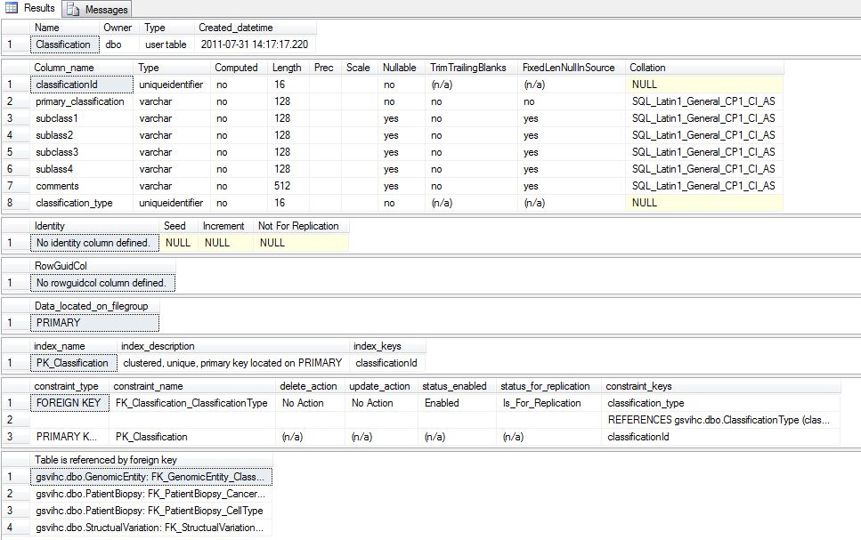
    - ClassificationType Table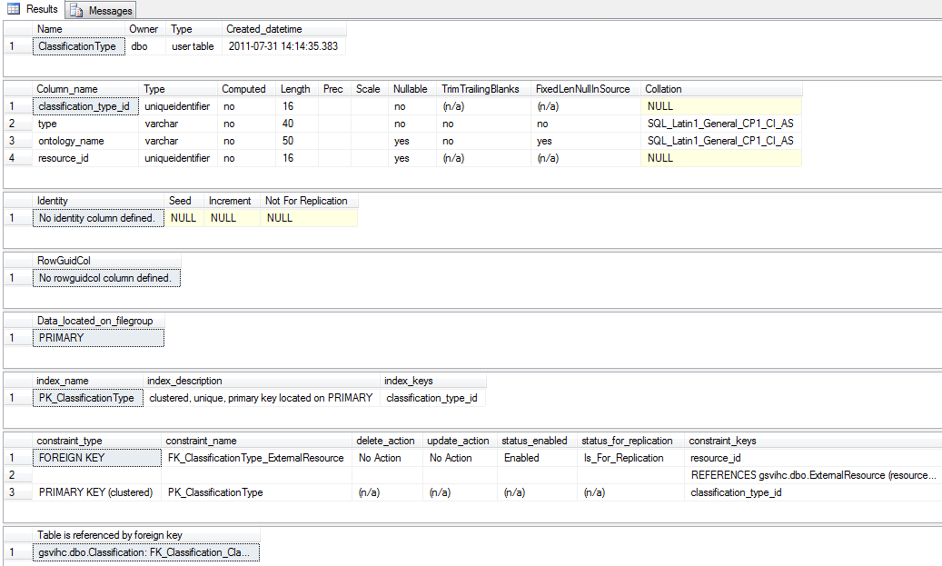
    - ClinicalNote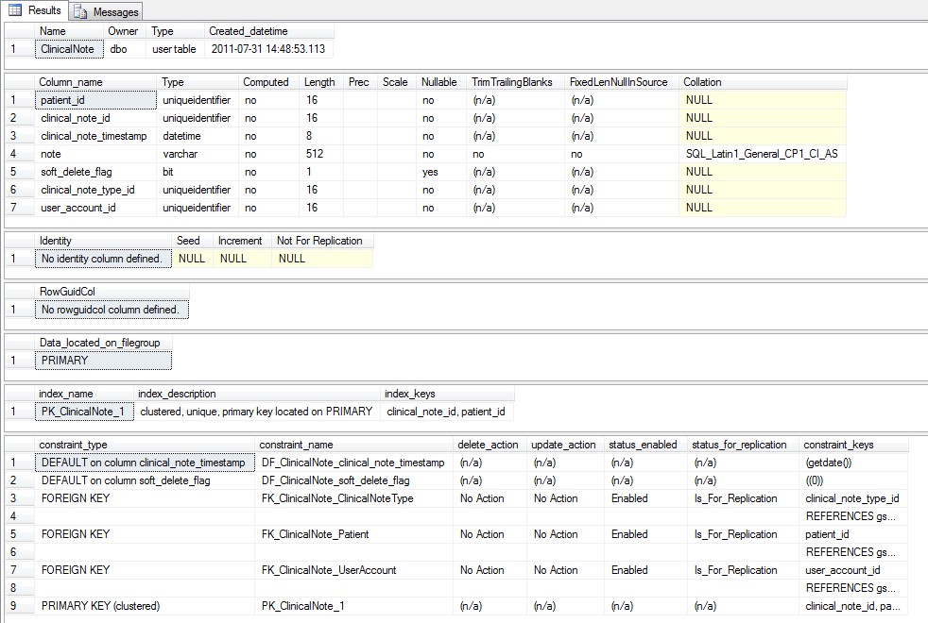
    - ClinicalNoteType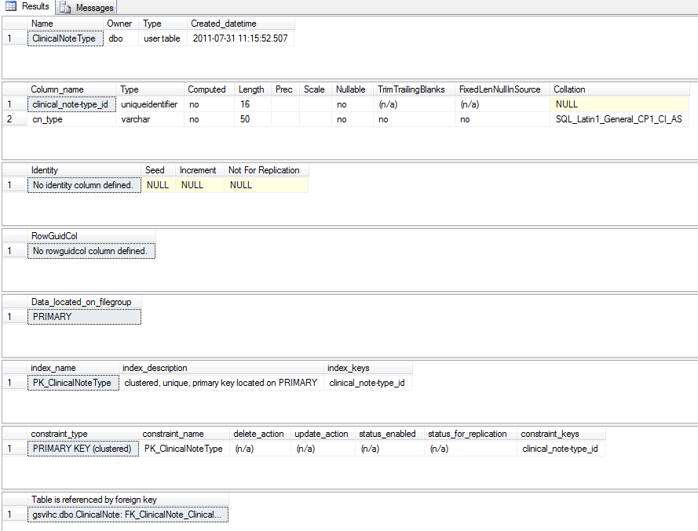
    - ExternalReference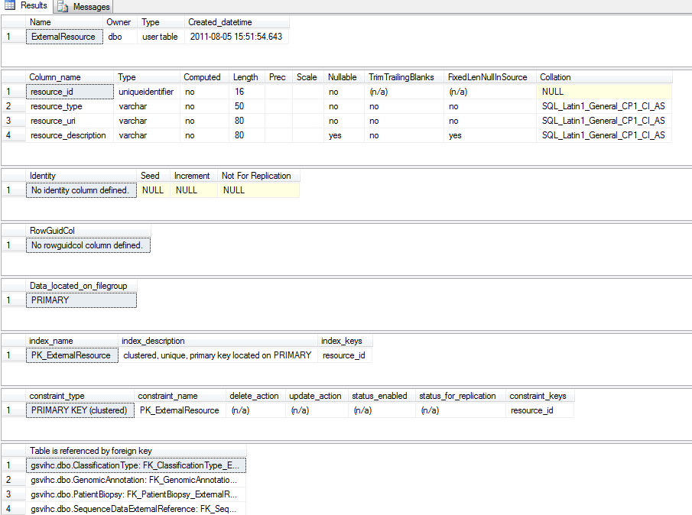
    - Gene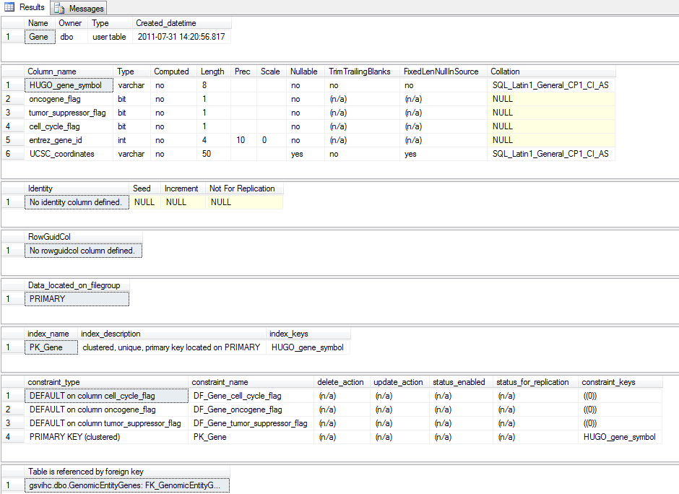
    - GenomicAnalysis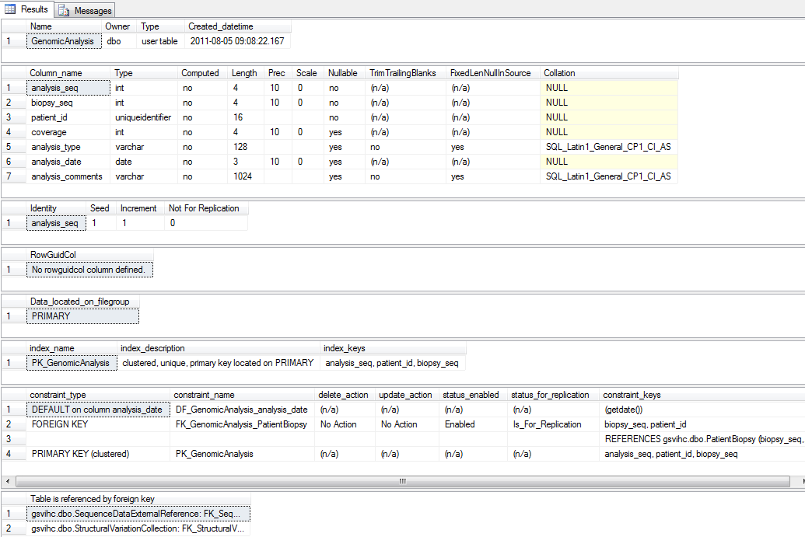
    - GenomicAnnotation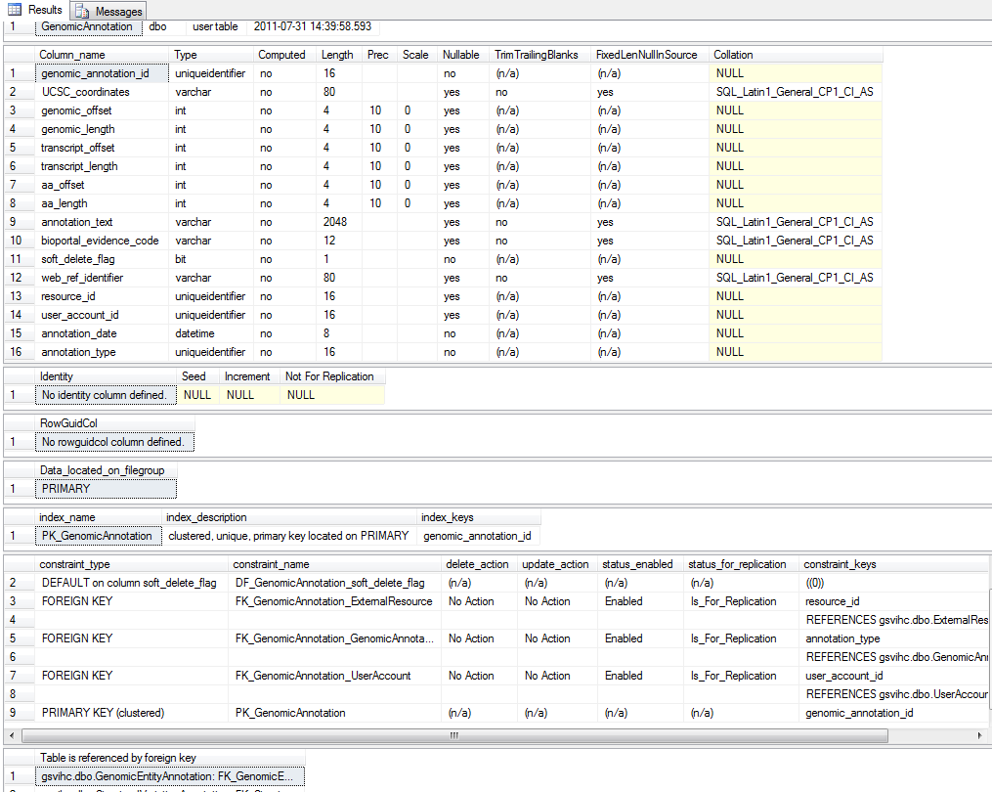
    - GenomicAnnotationType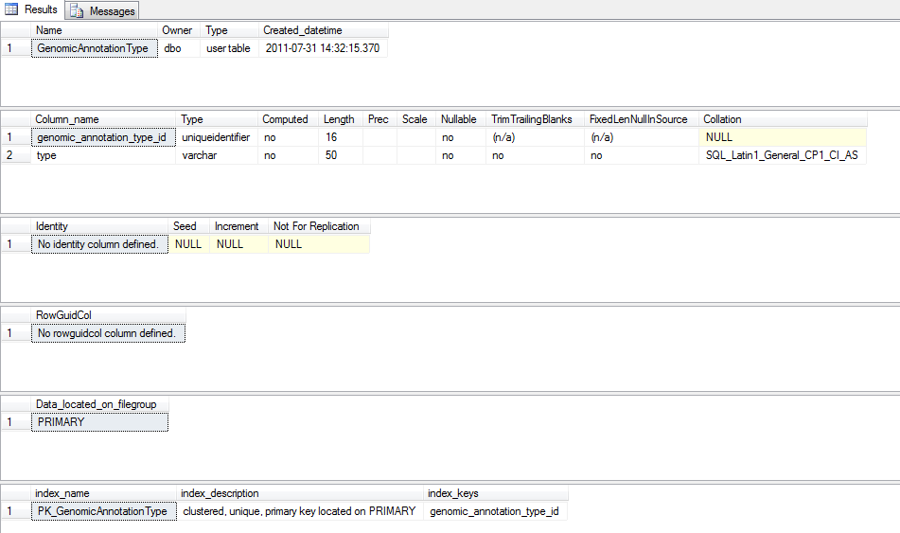
    - GenomicEntity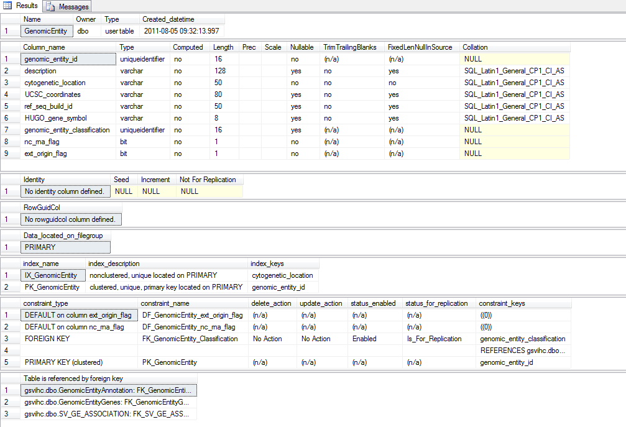
    - GenomicEntityGenes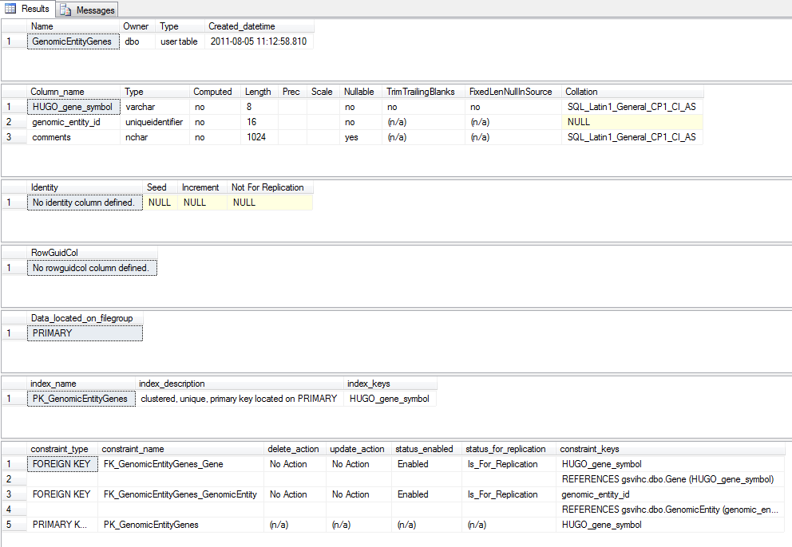
    - Patient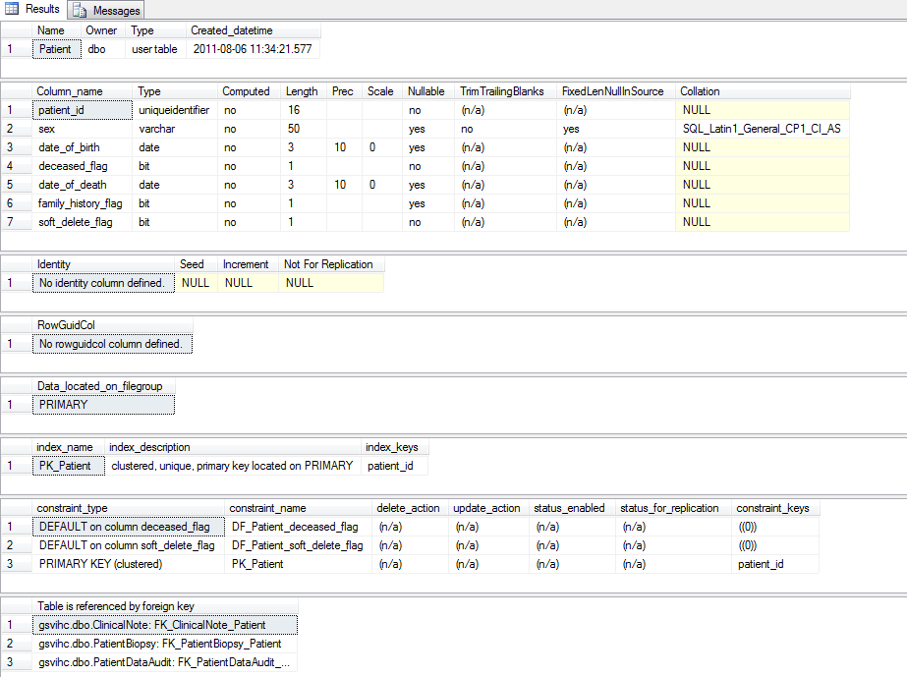
    - PatientBiopsy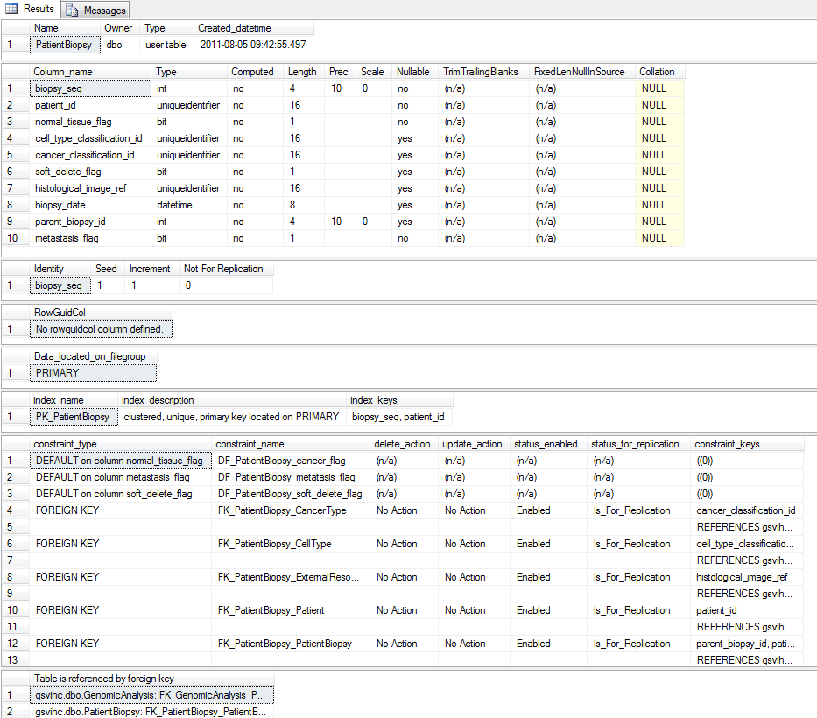
    - PatientDataAudit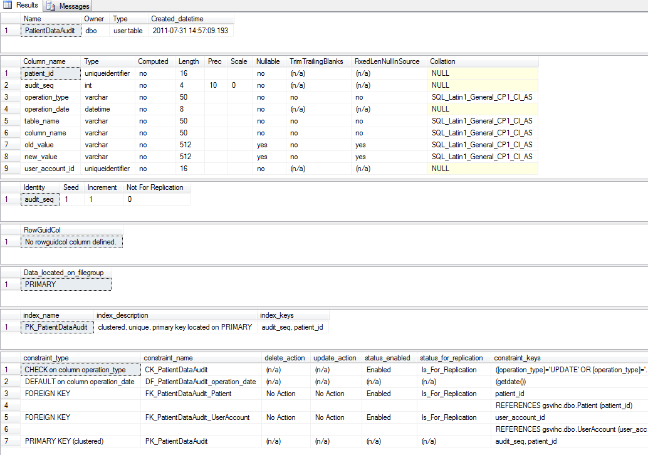
    - SequenceDataExternalReference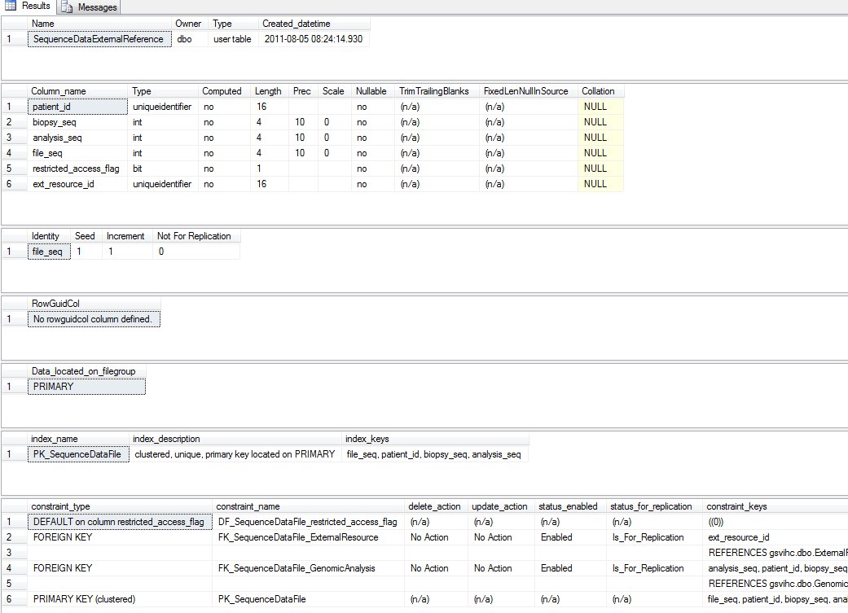
    - StructuralVariation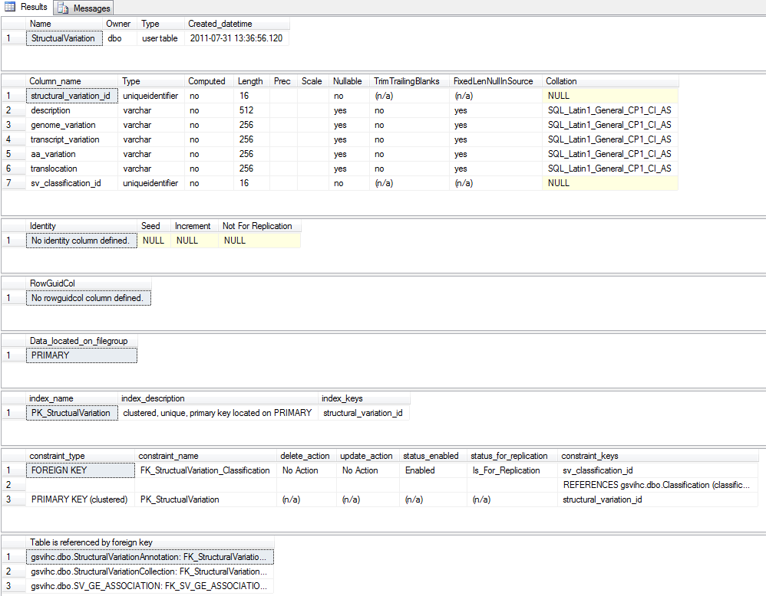
    - StructuralVariationCollection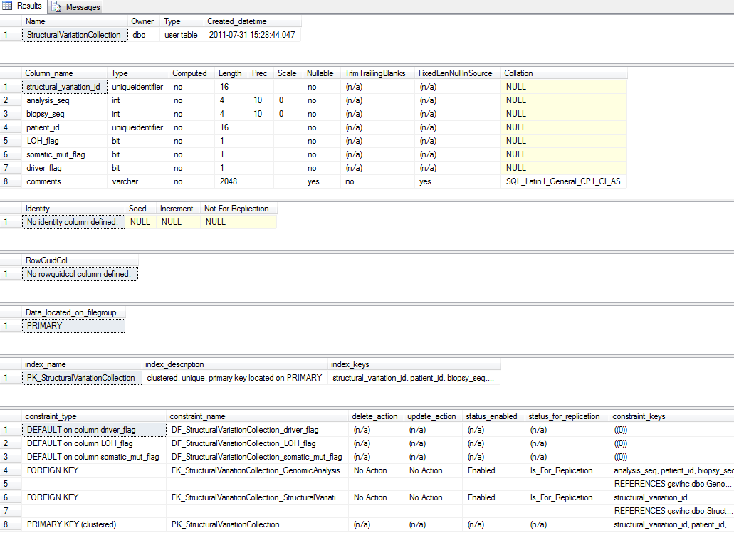
    - UserAccount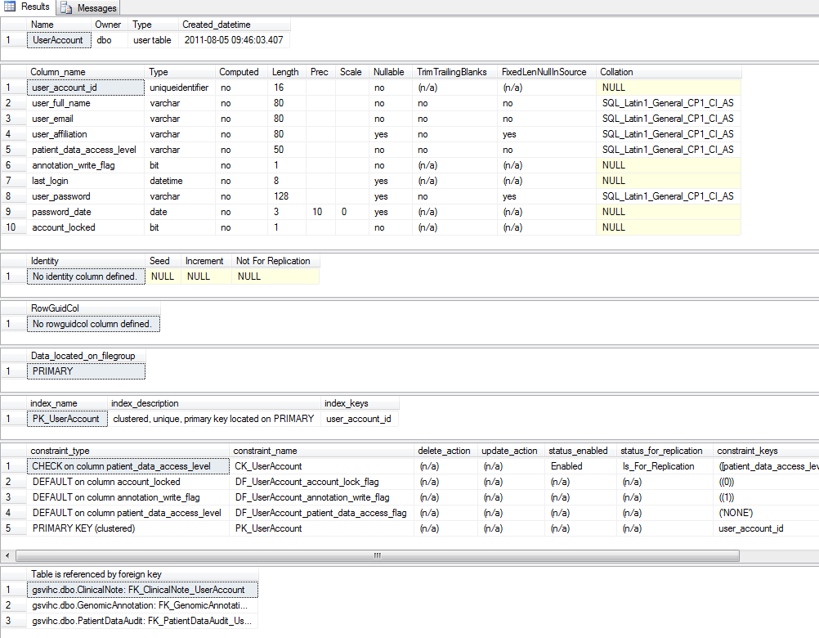

  - User Interface
N/A
  - Sample Queries
Find details about patients with structural variations in the tumor suppressor gene BRCA1
select *

from Patient p, Gene g, GenomicEntity ge , StructualVariation sv, StructuralVariationCollection svc,
PatientBiopsy pb, SV_GE_ASSOCIATION assoc
where p.patient_id = pb.patient_id
and pb.biopsy_seq = svc.biopsy_seq
and pb.patient_id = svc.patient_id
and svc.structural_variation_id = sv.structural_variation_id
and sv.structural_variation_id = assoc.structural_variation_id
and assoc.genomic_entity_id = ge.genomic_entity_id
and ge.HUGO_gene_symbol = g.HUGO_gene_symbol
and g.HUGO_gene_symbol = 'BRCA1'

Results
patient_id | 8D50304C-3E0F-412B-B051-78AFBA876F1E
sex | MALE
date_of_birth | 1956-01-11
deceased_flag | 0
date_of_death | NULL
family_history_flag | 0
soft_delete_flag | 0
HUGO_gene_symbol | BRCA1
oncogene_flag | 0
tumor_suppressor_flag | 1
cell_cycle_flag | 0
entrez_gene_id | 672
UCSC_coordinates | chr17:38,449,840-38,530,994
genomic_entity_id | F95F1F30-B8D6-4968-B665-350668E20649
description | BRCA1 gene
cytogenetic_location | 17q21.31
UCSC_coordinates | chr17:38,449,840-38,530,994
ref_seq_build_id | build 37
HUGO_gene_symbol | BRCA1
genomic_entity_classification | 4D2CB95B-A8C1-4A39-BEB4-8BF603C09363
nc_rna_flag | 0
ext_origin_flag | 0
structural_variation_id | 35285AD2-1E94-46AE-8C3C-3E2D3D773D34
description | indel results in frameshift
genome_variation | EWSR1{NM_005243.1}:r.1_1337+1052_NR4A3{NM_006981.2}:r.728-1754_5635
transcript_variation | NULL
aa_variation | NULL
translocation | NULL
sv_classification_id | A21BDB52-4625-47D8-9403-33D48981E1BF
structural_variation_id | 35285AD2-1E94-46AE-8C3C-3E2D3D773D34
biopsy_seq | 1
patient_id | 8D50304C-3E0F-412B-B051-78AFBA876F1E
LOH_flag | 0
somatic_mut_flag | 1
driver_flag | 1
comments | Driver mutation for breast cancer
biopsy_seq | 1
patient_id | 8D50304C-3E0F-412B-B051-78AFBA876F1E
normal_tissue_flag | 0
cell_type_classification_id | 1CB9C0EB-B182-4AE5-8874-0664965C1017
cancer_classification_id | 7049E207-269D-455B-8927-F15E7BF8C64D
soft_delete_flag | 0
histological_image_ref | NULL
biopsy_date | NULL
parent_biopsy_id | NULL
metastasis_flag | 0
structural_variation_id | 35285AD2-1E94-46AE-8C3C-3E2D3D773D34
genomic_entity_id | F95F1F30-B8D6-4968-B665-350668E20649

Find external references for gene symbol BRCA1
select er.resource_description, er.resource_uri, ga.web_ref_identifier
from GenomicEntity ge, GenomicEntityAnnotation gea,
ExternalResource er, GenomicAnnotation ga
where ge.genomic_entity_id = gea.genomic_entity_id
and gea.genomic_annotation_id = ga.genomic_annotation_id
and ga.resource_id = er.resource_id
and ge.HUGO_gene_symbol = 'BRCA1'

resource_description | OMIM
resource_uri | http://omim.org/entry/
web_ref_identifier | 114480

Find incidents of cancers associated with environmental factors

select p.sex, p.date_of_death, p.date_of_death,
pb.metastasis_flag, c.primary_classification,
cn.note
from Patient p, PatientBiopsy pb, ClinicalNote cn, clinicalnotetype cnt,
Classification c, ClassificationType ct
where pb.patient_id = p.patient_id
and cn.patient_id = p.patient_id
and cn.clinical_note_type_id = cnt.[clinical_note-type_id]
and pb.cancer_classification_id = c.classificationId
and c.classification_type = ct.classification_type_id
and cnt.cn_type like '%Environ%'

sex | MALE
date_of_birth | 1956-01-11
date_of_death | NULL
metastasis_flag | 0
primary_classification | Tumor cells, benign
note | The patient is a chronic smoker

A clinician needs to find genomic information about a patient’s structural variations and any external information available:

select p.patient_id, sv.genome_variation, ge.cytogenetic_location,
ge.UCSC_coordinates, er.resource_description, er.resource_uri ,ga.web_ref_identifier
from Patient p, PatientBiopsy pb,
StructuralVariationCollection svc, StructualVariation sv,
SV_GE_ASSOCIATION svgea, GenomicEntity ge,
GenomicEntityAnnotation gea, GenomicAnnotation ga,
ExternalResource er
where p.patient_id = pb.patient_id
and svc.patient_id = pb.patient_id
and svc.biopsy_seq = pb.biopsy_seq
and sv.structural_variation_id = svc.structural_variation_id
and svgea.structural_variation_id = sv.structural_variation_id
and svgea.genomic_entity_id = ge.genomic_entity_id
and gea.genomic_entity_id = ge.genomic_entity_id
and gea.genomic_annotation_id = ga.genomic_annotation_id
and ga.resource_id = er.resource_id
and p.patient_id = '8d50304c-3e0f-412b-b051-78afba876f1e'

Results:
patient_id | 8D50304C-3E0F-412B-B051-78AFBA876F1E
genome_variation | EWSR1{NM_005243.1}:r.1_1337+1052_NR4A3{NM_006981.2}:r.728-1754_5635
cytogenetic_location | 17q21.31
UCSC_coordinates | chr17:38,449,840-38,530,994
resource_description | OMIM
resource_uri | http://omim.org/entry/
web_ref_identifier | 114480

- CRUD Matrix

- Concluding Remarks
The Genomic Structural Variation In Human Cancer (GSVIHC) database is a compact relational database that supports the persistence of a wide range of oncology data. The design meets in primary object, the ability to track the catalog of structural variations within a tumor as the disease progresses, goes into remission, or spreads to a secondary site.

The use of annotation entities provides users with significant control over the contents within each database instance. The database’s support for external reference sources allows the application layer to supplement the database’s content with an overwhelming array of data and Web-based data services. This unstructured content is controlled by metadata classification and type entities. The former can be constrained by conforming to a published ontology. As noted, strong typing, simplifies queries across unstructured data.
GSVIHC implements a reasonable security model regarding patient privacy concerns given that it does not directly persist patient identifying attributes. The current design imposes most of the responsibility for security upon the application layer but given the potential liabilities it is a responsibility that few institutions will ignore.

Appendices

- Test Data
- Data Dictionary Index
SQL Server query:

SELECT
c.name AS ColumnName
,OBJECT_NAME(c.OBJECT_ID) TableName
,t.name AS TypeName
,c.max_length
,c.PRECISION

FROM sys.columns AS c
JOIN sys.types AS t ON c.user_type_id=t.user_type_id

ORDER BY c.name;
GO

Column Name | Table name | Type | Max | Length
aa_length | GenomicAnnotation | int | 4 | 10
aa_offset | GenomicAnnotation | int | 4 | 10
aa_variation | StructualVariation | varchar | 256 | 0
account_locked | UserAccount | bit | 1 | 1
algorithm | sysasymkeys | char | 2 | 0
analysis_comments | GenomicAnalysis | varchar | 1024 | 0
analysis_date | GenomicAnalysis | date | 3 | 10
analysis_seq | SequenceDataExternalReference | int | 4 | 10
analysis_seq | GenomicAnalysis | int | 4 | 10
analysis_seq | StructuralVariationCollection | int | 4 | 10
analysis_type | GenomicAnalysis | varchar | 128 | 0
annotation_date | GenomicAnnotation | datetime | 8 | 23
annotation_text | GenomicAnnotation | varchar | 2048 | 0
annotation_type | GenomicAnnotation | uniqueidentifier | 16 | 0
annotation_write_flag | UserAccount | bit | 1 | 1
audit_seq | PatientDataAudit | int | 4 | 10
bioportal_evidence_code | GenomicAnnotation | varchar | 12 | 0
biopsy_date | PatientBiopsy | datetime | 8 | 23
biopsy_seq | PatientBiopsy | int | 4 | 10
biopsy_seq | StructuralVariationCollection | int | 4 | 10
biopsy_seq | GenomicAnalysis | int | 4 | 10
biopsy_seq | SequenceDataExternalReference | int | 4 | 10
cancer_classification_id | PatientBiopsy | uniqueidentifier | 16 | 0
cell_cycle_flag | Gene | bit | 1 | 1
cell_type_classification_id | PatientBiopsy | uniqueidentifier | 16 | 0
classification_type | Classification | uniqueidentifier | 16 | 0
classification_type_id | ClassificationType | uniqueidentifier | 16 | 0
classificationId | Classification | uniqueidentifier | 16 | 0
clinical_note_id | ClinicalNote | uniqueidentifier | 16 | 0
clinical_note_timestamp | ClinicalNote | datetime | 8 | 23
clinical_note_type_id | ClinicalNote | uniqueidentifier | 16 | 0
clinical_note-type_id | ClinicalNoteType | uniqueidentifier | 16 | 0
cn_type | ClinicalNoteType | varchar | 50 | 0
column_name | PatientDataAudit | varchar | 50 | 0
comments | StructuralVariationCollection | varchar | 2048 | 0
comments | GenomicEntityGenes | nchar | 1024 | 0
comments | Classification | varchar | 512 | 0
coverage | GenomicAnalysis | int | 4 | 10
cytogenetic_location | GenomicEntity | varchar | 50 | 0
deceased_flag | Patient | bit | 1 | 1
description | StructualVariation | varchar | 512 | 0
description | GenomicEntity | varchar | 128 | 0
driver_flag | StructuralVariationCollection | bit | 1 | 1
entrez_gene_id | Gene | int | 4 | 10
ext_origin_flag | GenomicEntity | bit | 1 | 1
ext_resource_id | SequenceDataExternalReference | uniqueidentifier | 16 | 0
family_history_flag | Patient | bit | 1 | 1
file_seq | SequenceDataExternalReference | int | 4 | 10
genome_variation | StructualVariation | varchar | 256 | 0
genomic_annotation_id | GenomicAnnotation | uniqueidentifier | 16 | 0
genomic_annotation_id | GenomicEntityAnnotation | uniqueidentifier | 16 | 0
genomic_annotation_id | StructuralVariationAnnotation | uniqueidentifier | 16 | 0
genomic_annotation_type_id | GenomicAnnotationType | uniqueidentifier | 16 | 0
genomic_entity_classification | GenomicEntity | uniqueidentifier | 16 | 0
genomic_entity_id | SV_GE_ASSOCIATION | uniqueidentifier | 16 | 0
genomic_entity_id | GenomicEntityAnnotation | uniqueidentifier | 16 | 0
genomic_entity_id | GenomicEntity | uniqueidentifier | 16 | 0
genomic_entity_id | GenomicEntityGenes | uniqueidentifier | 16 | 0
genomic_length | GenomicAnnotation | int | 4 | 10
genomic_offset | GenomicAnnotation | int | 4 | 10
histological_image_ref | PatientBiopsy | uniqueidentifier | 16 | 0
HUGO_gene_symbol | GenomicEntity | varchar | 8 | 0
HUGO_gene_symbol | GenomicEntityGenes | varchar | 8 | 0
HUGO_gene_symbol | Gene | varchar | 8 | 0
LOH_flag | StructuralVariationCollection | bit | 1 | 1
nc_rna_flag | GenomicEntity | bit | 1 | 1
normal_tissue_flag | PatientBiopsy | bit | 1 | 1
note | ClinicalNote | varchar | 512 | 0
old_value | PatientDataAudit | varchar | 512 | 0
oncogene_flag | Gene | bit | 1 | 1
ontology_name | ClassificationType | varchar | 50 | 0
operation_date | PatientDataAudit | datetime | 8 | 23
operation_type | PatientDataAudit | varchar | 50 | 0
parent_biopsy_id | PatientBiopsy | int | 4 | 10
password_date | UserAccount | date | 3 | 10
patient_data_access_level | UserAccount | varchar | 50 | 0
patient_id | PatientBiopsy | uniqueidentifier | 16 | 0
patient_id | PatientDataAudit | uniqueidentifier | 16 | 0
patient_id | StructuralVariationCollection | uniqueidentifier | 16 | 0
patient_id | GenomicAnalysis | uniqueidentifier | 16 | 0
patient_id | SequenceDataExternalReference | uniqueidentifier | 16 | 0
patient_id | ClinicalNote | uniqueidentifier | 16 | 0
patient_id | Patient | uniqueidentifier | 16 | 0
primary_classification | Classification | varchar | 128 | 0
ref_seq_build_id | GenomicEntity | varchar | 50 | 0
refcount | sysconvgroup | int | 4 | 10
resource_description | ExternalResource | varchar | 80 | 0
resource_id | GenomicAnnotation | uniqueidentifier | 16 | 0
resource_id | ClassificationType | uniqueidentifier | 16 | 0
resource_id | ExternalResource | uniqueidentifier | 16 | 0
resource_type | ExternalResource | varchar | 50 | 0
resource_uri | ExternalResource | varchar | 80 | 0
restricted_access_flag | SequenceDataExternalReference | bit | 1 | 1
soft_delete_flag | Patient | bit | 1 | 1
soft_delete_flag | GenomicAnnotation | bit | 1 | 1
soft_delete_flag | ClinicalNote | bit | 1 | 1
soft_delete_flag | PatientBiopsy | bit | 1 | 1
somatic_mut_flag | StructuralVariationCollection | bit | 1 | 1
structural_variation_id | StructuralVariationAnnotation | uniqueidentifier | 16 | 0
structural_variation_id | SV_GE_ASSOCIATION | uniqueidentifier | 16 | 0
structural_variation_id | StructuralVariationCollection | uniqueidentifier | 16 | 0
structural_variation_id | StructualVariation | uniqueidentifier | 16 | 0
subclass1 | Classification | varchar | 128 | 0
subclass2 | Classification | varchar | 128 | 0
subclass3 | Classification | varchar | 128 | 0
subclass4 | Classification | varchar | 128 | 0
transcript_length | GenomicAnnotation | int | 4 | 10
transcript_offset | GenomicAnnotation | int | 4 | 10
transcript_variation | StructualVariation | varchar | 256 | 0
translocation | StructualVariation | varchar | 256 | 0
type | ClassificationType | varchar | 40 | 0
type | GenomicAnnotationType | varchar | 50 | 0
UCSC_coordinates | GenomicAnnotation | varchar | 80 | 0
UCSC_coordinates | GenomicEntity | varchar | 80 | 0
UCSC_coordinates | Gene | varchar | 50 | 0
user_account_id | GenomicAnnotation | uniqueidentifier | 16 | 0
user_account_id | ClinicalNote | uniqueidentifier | 16 | 0
user_account_id | PatientDataAudit | uniqueidentifier | 16 | 0
user_account_id | UserAccount | uniqueidentifier | 16 | 0
user_affiliation | UserAccount | varchar | 80 | 0
user_email | UserAccount | varchar | 80 | 0
user_full_name | UserAccount | varchar | 80 | 0
user_password | UserAccount | varchar | 128 | 0
web_ref_identifier | GenomicAnnotation | varchar | 80 | 0

A complete list of Windows operating systems that support Microsoft SQL Server 2008 can be found at: http://msdn.microsoft.com/en-us/library/ms143506.aspx#SE32
The database does persist the build number for the reference sequence used for the genomic entity. This allows the correct reference sequence to be requested from the external resource.
http://circos.ca
HUGO Gene Nomenclature Committee http://www.genenames.org
NCBI Entrez search engine http://www.ncbi.nlm.nih.gov/sites/gquery
UCSC Genome Browser http://genome.ucsd.edu
NCBO Evidence Ontology http://bioportal.bioontology.org/ontologies/45770?p=terms
The deceased_flag attribute is necessary when it is known that the patient is deceased but the date of death is unknown. If known, the date_of_death attribute is a useful supplement to determine the patient’s lifespan.
The parent of a biopsy may not be its immediate predecessor in time. If a cancer successively spreads from a primary site to two different secondary sites, the parent for biopsies at both secondary sites will be the primary.
Health Insurance Portability and Accountability Act http://www.hhs.gov/ocr/privacy/

